**PL/SQL**

**Exercise 3: Stored Procedures**

**Scenario 1:**

Question: Write a stored procedure ProcessMonthlyInterest that calculates and updates the balance of all savings accounts by applying an interest rate of 1% to the current balance.

CREATE OR REPLACE PROCEDURE ProcessMonthlyInterest IS

BEGIN

FOR acc IN (

SELECT AccountID, Balance

FROM Accounts

WHERE AccountType = 'Savings'

) LOOP

UPDATE Accounts

SET Balance = Balance + (acc.Balance * 0.01)

WHERE AccountID = acc.AccountID;

END LOOP;

COMMIT;

END;

**OUTPUT:**



**Scenario 2:**

Question: Write a stored procedure UpdateEmployeeBonus that updates the salary of employees in a given department by adding a bonus percentage passed as a parameter

CREATE OR REPLACE UpdateEmployeeBonus (

p_Department IN VARCHAR2(100),

p_bonus_percentage IN NUMBER

)IS

BEGIN

UPDATE Employees

SET Salary=Salary+(Salary*p_bonus_percentage/100)

WHERE Department=p_Department;

END;

**OUTPUT:**



**Scenario 3:**

Question: Write a stored procedure TransferFunds that transfers a specified amount from one account to another, checking that the source account has sufficient balance before making the transfer

CREATE OR REPLACE PROCEDURE TransferFunds(

p_FromAccountID IN NUMBER,

p_ToAccountID IN NUMBER,

p_Amount IN NUMBER

) IS

v_FromBalance NUMBER;

BEGIN

SELECT Balance INTO v_FromBalance

FROM Accounts

WHERE AccountID = p_FromAccountID;

IF v_FromBalance < p_Amount THEN

DBMS_OUTPUT.PUT_LINE('Insufficient funds in source account.');

ELSE

UPDATE Accounts

SET Balance = Balance - p_Amount

WHERE AccountID = p_FromAccountID;

UPDATE Accounts

SET Balance = Balance + p_Amount

WHERE AccountID = p_ToAccountID;

DBMS_OUTPUT.PUT_LINE('Transfer successful.');

END IF;

END;

**OUTPUT:**

Before Transfer

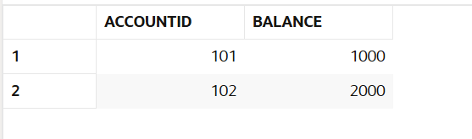

After Transfer



Insufficient fund

